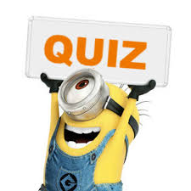 | Year 12 Methods  Term 5 Week 7 Quiz | $$\frac{}{16}$$

Name: __________________
1. | Malcolm devises the following game. He will toss two dice, and if a ‘double’ is observed he will pay his friend $3.60, otherwise his friend must pay him 60 cents. How much will Malcolm expect to win or lose per game in the long run using this strategy? | 3
2. | Suppose that X is the number of times a shooter hits a target in a competition. If the distribution of X is binomial, with probability of success of 0.67, calculate the probability that a shooter who takes five shots will hit the target three times. | 2
4. | A multiple choice test has 10 questions, each of whci has five possible answers. Find the probabillity that a student who guesses the answer to each question will have:  - No correct answers  - 5 or more correct answers  - At least 7 correct answers given that they have at least 5 correct answers. | 4
8. |  | 7

